Program – 1
Program to enter two numbers and print the arithmetic operations like +,-,*,/, // and %.
Code
val1 = float(input("Enter the first value :"))
val2 = float(input("Enter the second value :"))
op = input("Enter any one of the operator (+,-,*,/,//,%)")
if op == "+":
result = val1 + val2
elif op == "-":
result = val1 - val2
elif op == "*":
result = val1 * val2
elif op == "/":
if val2 == 0:
print("Please enter a value other than 0")
else:
result = val1 / val2
elif op == "//":
result = val1 // val2
else:
result = val1 % val2
print("The result is :",result)

Output:
Enter the first value :50

Enter the second value :24

Enter any one of the operator (+, -, *, /, / /,%) +

The result is : 74.0

Program – 2
Write a Program to check if the entered number is Armstrong or not.
Code
no=int(input("Enter any number to check : "))
no1 = no
sum = 0
while no>0 :
ans = no % 10;
sum = sum + (ans * ans * ans)
no = int (no / 10)
if sum == no1:
print("Armstrong Number")
else:
print("Not an Armstrong Number")

Output:
Enter any number to check: 153

Armstrong Number

Program – 3
Write a Program to read the content of file and display the total number of consonants, uppercase, vowels and lower case characters.
Code
f = open("file1.txt")
v=0
c=0
u=0
l=0
o=0
data = f.read()
vowels=['a','e','i','o','u']
for ch in data:
if ch.isalpha():
if ch.lower() in vowels:
v+=1
else:
c+=1
if ch.isupper():
u+=1
elif ch.islower():
l+=1
elif ch!=' ' and ch!='\n':
o+=1
print("Total Vowels in file :",v)
print("Total Consonants in file :",c)
print("Total Capital letters in file :",u)
print("Total Small letters in file :",l)
print("Total Other than letters :",o)
f.close()
Output:
Total Vowels in file : 16
Total Consonants in file n: 30
Total Capital letters in file :2
Total Small letters in file : 44
Total Other than letters :
File Content:
NOTE : if the original content of file is:
India is my countryI love python Python learning is fun123@

Program – 4
Write a Program to read the content of file line by line and write it to another file except for the lines contains “a” letter in it.

Code
f1 = open("file2.txt")
f2 = open("file2copy.txt","w")
for line in f1:
if 'a' not in line:
f2.write(line)
print(“## File Copied Successfully! ##”)
f1.close()
f2.close()
Output
NOTE : contant of file2.txt
a quick brown fox
one two three four
five six seven
eight nine ten
bye!

Program – 5
Program to create binary file to store Rollno and Name, Search any Rollno and display name if Rollno found otherwise “Rollno not found”

Code

import pickle
def write():
D={ }
f=open("Studentdetails.dat","wb")
while True:
r = int(input ("Enter Roll no : "))
n = input("Enter Name : ")
D['Roll No'] = r
D['Name'] = n
pickle.dump(D,f)
ch = input("More ? (Y/N)")
if ch in 'Nn':
break
f.close()

def Search() :
found = 0
rollno= int(input("Enter Roll no Whose name you want to display :"))
f = open("Studentdetails.dat", "rb")
try:
while True:
rec = pickle.load(f)
if rec['Roll No']==rollno:
print(rec['Name'])
found = 1
break
except EOFError:
if found == 0:
print("Sorry not Found....")
f.close()

write()
Search()
Program – 5

Output

Enter Roll no: 1

Enter Name: s

More? (Y/N)n

Enter Roll no Whose name you want to display:1 S

[Program finished]
Program – 6
Program to create binary file to store Rollno, Name and Marks and update marks of entered Rollno.

Code

import pickle
def write():
D={}
f=open("Studentdetails.dat","wb")
while True:
r = int(input ("Enter Roll no : "))
n = input("Enter Name : ")
D['Roll No'] = r
D['Name'] = n
pickle.dump(D,f)
ch = input("More ? (Y/N)")
if ch in 'Nn':
break
f.close()

def Update():
f = open("Studentdetails.dat", 'rb+')
rollno = int(input("Enter roll no whoes marks you want to update"))
try:
while True:
pos=f.tell()
rec = pickle.load(f)
if rec[0]==rollno:
um = int(input("Enter Update Marks:"))
rec[2]=um
f.seek(pos)
pickle.dump(rec,f)
except EOFError:
print("Sorry entered roll no not Found....")
f.close()

write( )
Update( )
Program – 6

Output:
Enter Roll no : 1
Enter Name : jiya
Enter Marks : 56
Do you want to enter more ?(Y/N)y
Enter Roll no : 2
Enter Name : henil
Enter Marks: 67
Do you want to enter more ?(Y/N)n
[1, 'jiya', 56]
[2, 'henil', 67]
Enter roll no whose marks you want to update : 2
Enter Update Marks:76
[1, 'jiya', 56]
[2, 'henil', 76]

Program – 7
Write a Python program to implement all basic operations of a stack, such as adding element (PUSH operation), removing element (POP operation) and displaying the stack elements (Traversal operation) using lists.
Code
s=[ ]
c="y"
while c=="y":
print ("1. PUSH")
print ("2. POP ")
print ("3. Display")
choice=int(input("Enter your choice: "))
if choice==1:
a=input("Enter any number :")
s.append(a)
elif choice==2:
if s==[ ]:
print ("Stack Empty")
else:
print ("Deleted element is : ",s.pop())
elif choice==3:
l=len(s)
for i in range(l-1,-1,-1): #To display elements from last element to first
print (s[i])
else:
print("Wrong Input")
c=input("Do you want to continue or not? ")
Output:
1. PUSH
2. POP
3. Display
Enter your choice: 1
Enter any number:20
Do you want to continue or not? y
1. PUSH
2. POP
3. Display
Enter your choice: 2
Deleted element is: 20
Do you want to continue or not? y
1. PUSH
2. POP
3. Display
Enter your choice: 3
Do you want to continue or not? n

Program – 8
Write a program to implement a stack for the employee details (empno,name)

Code

employee=[]
def push():
empno=input("Enter empno ")
name=input("Enter name ")
sal=input("Enter sal ")
emp=(empno,name,sal)
employee.append(emp)
def pop():
if(employee==[]):
print("Underflow / Employee Stack in empty")
else:
empno,name,sal=employee.pop()
print("poped element is ")
print("empno ",empno," name ",name," salary ",sal)
def traverse():
if not (employee==[]):
n=len(employee)
for i in range(n-1,-1,-1):
print(employee[i])
else:
print("Empty , No employee to display")
while True:
print("1. Push")
print("2. Pop")
print("3. Traversal")
print("4. Exit")
ch=int(input("Enter your choice "))
if ch==1:
push()
elif ch==2:
pop()
elif ch==3:
traverse()
elif ch==4:
print("End")
break
else:
print("Invalid choice")
Program – 8
Output:
1. Push

2. Pop

3. Traversal

4. Exit

Enter your choice 1

Enter empno 12

Enter name jayna

Enter sal 30000

1. Push

2. Pop

3. Traversal

4. Exit

Enter your choice 3

('12', 'jayna', '30000')

1. Push

2. Pop

3. Traversal

4. Exit

Program – 9
Write a Program to generate random number 1-6, simulating a dice.

Code

import random
while True:
print("="*55)
print("***********************Roling Dice****************************")
print("="*55)
num = random.randint(1,6)
if num ==6:
print("Hey.....You got",num,"........Congratulations!!!!")
elif num ==1:
print("Well tried.... But you got",num)
else:
print("You got:",num)
ch=input("Roll again? (Y/N)")
if ch in "Nn":
break
print("Thank for playing!!!!!!!!")

Output:
===================================================
***********************Roling Dice*****************************
===================================================

You got: 2

Roll again? (Y/N)y

Thank for playing!!!!!!!!
===================================================
***********************Roling Dice*****************************
===================================================

Hey..... You got 6 ........ Congratulations!!!!

===================================================
Program – 10
Write a program using python to get 10 players name and their score. Write the input in a csv file. Accept a player name using python. Read the csv file to display the name and the score. If the player name is not found give an appropriate message.

Code
import csv
with open('player.csv','w') as f:
w = csv.writer(f)
n=1
while (n<=10):
name = input("Player Name?:" )
score = int(input("Score: "))
w.writerow([name,score])
n+=1
print("Player File created")
f.close()

searchname=input("Enter the name to be searched ")
f=open('player.csv','r')
reader =csv.reader(f)
lst=[ ]
for row in reader:
lst.append(row)
q=0
for row in lst:
if searchname in row:
print(row)
q+=1
if q==0:
print("Record not found")
f.close()
Program – 10

Output:
Player Name?:Rohit Sharma
Score: 264
Player Name?:VirenderSehwag
Score: 219
Player Name?:Sachin Tendulkar
Score: 200
Player Name?:Dhoni
Score: 190
Player Name?:Sachin Tendulkar
Score: 250
Player Name?:Virat Kohli
Score: 148
Player Name?:Ganguly
Score: 158
Player Name?:KapilDev
Score: 175
Player Name?:Amarnath
Score: 148
Player Name?:SunilGavaskar
Score: 200
Player File created

Program – 11
Program to create CSV file and store empno, name, salary and search any empno and display name, salary and if not found appropriate message.

Code
import csv
with open('myfile.csv',mode='a') as csvfile:
mywriter = csv.writer(csvfile,delimiter=',')
ans='y'
while ans.lower()=='y':
eno=int(input("Enter Employee Number "))
name=input("Enter Employee Name ")
salary=int(input("Enter Employee Salary :"))
mywriter.writerow([eno,name,salary])
print("## Data Saved... ##")
ans=input("Add More ?")
ans='y'
with open('myfile.csv',mode='r') as csvfile:
myreader = csv.reader(csvfile,delimiter=',')
while ans=='y':
found=False
e = int(input("Enter Employee Number to search :"))
for row in myreader:
if len(row)!=0:
if int(row[0])==e:
print("============================")
print("NAME :",row[1]) print("SALARY :",row[2])
found=True
break
if not found:
print("==========================")
print(" EMPNO NOT FOUND")
print("==========================")
ans = input("Search More ? (Y)")

Program – 11
Output:
Enter Employee Number 1
Enter Employee Name Amit
Enter Employee Salary :90000
## Data Saved... ##
Add More ?y
Enter Employee Number 2
=========================
Enter Employee Name Sunil
Enter Employee Salary:80000
## Data Saved... ##
Add More ?y
Enter Employee Number 3
=========================
Enter Employee Name Satya
Enter Employee Salary:75000
## Data Saved... ##
Add More ?n
Enter Employee Number to search :2
NAME: Sunil
SALARY: 80000
Search More ? (Y)y
Enter Employee Number to search :3
NAME: Satya
SALARY: 75000

Program – 12
Write a Program to connect with database and store record of employee and display records.

Code
import mysql.connector as mycon
con = mycon.connect(host='localhost',user='root',passwd="admin")
cur = con.cursor()
cur.execute("create database if not exists company")
cur.execute("use company")
cur.execute("create table if not exists employee(empno int, name varchar(20), dept varchar(20),salary int)")
con.commit()
choice=None
while choice!=0:
print("1. ADD RECORD ")
print("2. DISPLAY RECORD ")
print("0. EXIT")
choice = int(input("Enter Choice :"))
if choice == 1:
e = int(input("Enter Employee Number :"))
n = input("Enter Name :")
d = input("Enter Department :")
s = int(input("Enter Salary :"))
query="insert into employee values({},'{}','{}',{})".format(e,n,d,s)
cur.execute(query)
con.commit()
print("## Data Saved ##")
elif choice == 2:
query="select * from employee"
cur.execute(query)
result = cur.fetchall()
print("%10s"%"EMPNO","%20s"%"NAME","%15s"%"DEPARTMENT",
"%10s"%"SALARY")
for row in result:
print("%10s"%row[0],"%20s"%row[1],"%15s"%row[2],"%10s"%row[3])
elif choice==0:
con.close()
print("## Bye!! ##")
else:
print("## INVALID CHOICE ##")
Program – 12
Output:
1. ADD RECORD
2. DISPLAY RECORD
0. EXI
Enter Choice : 1
Enter Employee Number:1
Enter Name :AMIT
Enter Department :SALES
Enter Salary :9000
## Data Saved ##
1. ADD RECORD
2. DISPLAY RECORD
0. EXIT
Enter Choice : 1
Enter Employee Number :2
Enter Name : NITIN
Enter Department :IT
Enter Salary :80000
## Data Saved ##
1. ADD RECORD
2. DISPLAY RECORD
0. EXIT
Enter Choice :2
EMPNO NAME DEPARTMENT SALARY
1. AMIT SALES 9000
2. NITIN IT 80000
1. ADD RECORD
2. DISPLAY RECORD
0. EXIT
Enter Choice :0
## Bye!! ##

Program – 13
Write a Program to show MySQL database connectivity in python demonstrate the use of fetchone( )
Consider a table student (Rno , Name , Class) exists in a database school

Code
import mysql.connector
con=mysql.connector.connect(host='localhost',user='root',passwd='',database='school')
stmt=con.cursor()
query='select * from student;'
stmt.execute(query)
data=stmt.fetchone()
print(data)

Output:
C:\Users\My Name>python demo_mysql_select_fetchone.py

(1, 'John', 'Highway 21')

Program – 14
Write a python program to Create a CSV file by entering user-id and password, read and search the password for given user- id.

Code
import csv
with open("7.csv", "w") as obj:
fileobj = csv.writer(obj)
fileobj.writerow(["User Id", "password"])
while(True):
user_id = input("enter id: ")
password = input("enter password: ")
record = [user_id, password]
fileobj.writerow(record)
x = input("press Y/y to continue and N/n to terminate the program\n")
if x in "Nn":
break
elif x in "Yy":
continue
with open("7.csv", "r") as obj2:
fileobj2 = csv.reader(obj2)
given = input("enter the user id to be searched\n")
for i in fileobj2:
if i[0] == given:
print(i[1])
break
Program – 14

Output:
enter id: cbse
enter password: 123
press Y/y to continue and N/n to terminate the program
y
enter id: computer_scienc
enter password: python
press Y/y to continue and N/n to terminate the program
y
enter id: class12
enter password: cs083
press Y/y to continue and N/n to terminate the program
n
enter the user id to be searched
cbse
123

Program – 15
Write a MySQL connectivity program in Python to:
- Create a database school
- Create a table students with the specifications - ROLLNO integer, STNAME
character(10) in MySQL and perform the following operations:
- Insert two records in it
- Display the contents of the table

Code
import mysql.connector
mydb = mysql.connector.connect host="localhost", user="root", password="root")
c=mydb.cursor ( )
def c_database():
try:
dn=input("Enter Database Name=")
c.execute("create database {}".format(dn))
c.execute("use {}".format(dn))
print("Database created successfully")
except Exception as a:
print("Database Error",a)

def d_database():
try:
dn=input("Enter Database Name to be dropped=")
c.execute("drop database {}".format(dn))
print("Database deleted sucessfully")
except Exception as a:
print("Database Drop Error",a)

def c_table():#Function to create Table
try:
c.execute("create table students(rollno int(3),stname varchar(20));")
print("Table created successfully")
except Exception as a:
print("Create Table Error",a)

def e_data():
try:
while True:
rno=int(input("Enter student rollno="))
name=input("Enter student name=")
c.execute("use {}".format('STD12'))
c.execute("insert into students values({},'{}');".format(rno,name))
mydb.commit()
choice=input("Do you want to add more record<y/n>=")
if choice in "Nn":
break
except Exception as a:
print("Insert Record Error",a)

def d_data():
try:
c.execute("select * from students")
data=c.fetchall()
for i in data:
print(i)
except Exception as a:
print("Display Record Error",a)
while True:
print("MENU\n1. Create Database\n2. Drop Database \n3. Create Table\n
4. Insert Record \n5 Display Entire Data\n6. Exit")
choice=int(input("Enter your choice<1-6>="))
if choice==1:
c_database()
elif choice==2:
d_database()
elif choice==3:
c_table()
elif choice==4:
e_data()
elif choice==5:
d_data()
elif choice==6:
break
else:
print("Wrong option selected")

Output
Program – 15

Output:
1. Create Database
2. Drop Database
3. Create Table
4. Insert Record
5. Display Entire Data
6. Exit
Enter your choice<1-6>=4
Enter student rollno=11
Enter student name=Raj
Do you want to add more record<y/n>=n
MENU
1. Create Database
2. Drop Database
3. Create Table
4. Insert Record
5. Display Entire Data
6. Exit
Enter your choice<1-6>=5 (11, 'Raj')
MENU
1. Create Database
2. Drop Database
3. Create Table
4. Insert Record
5. Display Entire Data
6. Exit
Enter your choice<1-6>=6

Program – 16
Write a MySQL connectivity program in Python to perform all the DML operations with reference to table ‘students’.

Code

import mysql.connector as ms
db=ms.connect( host="localhost", user="root", passwd="root",database="school")
cn=db.cursor()

def insert_rec():
try:
while True:
rn=int(input("Enter roll number:"))
sname=input("Enter name:")
marks=float(input("Enter marks:"))
gr=input("Enter grade:")
cn.execute("insert into student
values({},'{}',{},'{}')".format(rn,sname,marks,gr))
db.commit()
ch=input("Want more records? Press (N/n) to stop entry:")
if ch in 'Nn':
print("Record Inserted.....")
break
except Exception as e:
print("Error", e)

def update_rec():
try:
rn=int(input("Enter rollno to update:"))
marks=float(input("Enter new marks:"))
gr=input("Enter Grade:")
cn.execute("update student set marks={},gr='{}' where rn={}".format(marks,gr,rn))
db.commit()
print("Record Updated.....")
except Exception as e:
print("Error",e)

def delete_rec():
try:
rn=int(input("Enter rollno to delete:"))
cn.execute("delete from student where rn={}".format(rn))
db.commit()
print("Record Deleted.....")
except Exception as e:
print("Error",e)
def view_rec():
try:
cn.execute("select * from student")
records = cn.fetchall()
for record in records:
print(record)
except Exception as e:
print("Error",e)

while True:
print("MENU\n1. Insert Record\n2. Update Record \n3. Delete Record\n4.
Display Record \n5.Exit")
ch=int(input("Enter your choice<1-4>="))
if ch==1:
insert_rec()
elif ch==2:
update_rec()
elif ch==3:
delete_rec()
elif ch==4:
view_rec()
elif ch==5:
break
else:
print("Wrong option selected")

Program – 16

Output:
MENU
1. Insert Record
2. Update Record
3. Delete Record
4. Display Record
5. Exit
Enter your choice<1-4>=1
Enter roll number: 111
Enter name: Sagar
Enter marks:98
Enter grade: A1
Want more records? Press (N/n) to stop entry:y
Enter roll number: 114
Enter name: Vipul
Enter marks:83
Enter grade: A2
Want more records? Press (N/n) to stop entry:n
MENU
1. Insert Record
2. Update Record
3. Delete Record
4. Display Record
5. Exit
Enter your choice<1-4>=4
(1, 'Amrita', Decimal('88.00'), 'A2')
(102, Jay, Decimal ('98.00'), 'A1')
(111, 'Sagar', Decimal('98.00'), 'A1')

SQL
QUERIES
SET -1

Consider the following MOVIE table and write the SQL queries based on it.
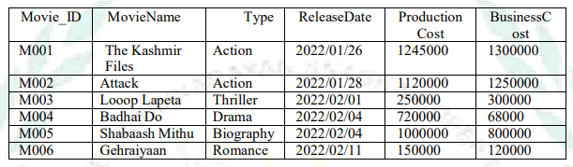
a) Display all information from movie.
Select * from MOVIES;

b) Display the type of movies.
SELECT DISTINCT TYPE FROM MOVIE;

c) Display movieid, moviename, total_eraning by showing the business done by the movies.
Calculate the business done by movie using the sum of production cost and business cost.
SELECT MOVIE_ID,MOVIENAME,PRODUCTIONCOST + BUSINESSCOST “TOTAL COST” FROM MOVIES;

d) Display movieid, moviename and productioncost for all movies with production cost greater
than 150000 and less than 1000000.
SELECT MOVIE_ID,MOVIENAME,PRODUCTION COST FROM MOVIES WHERE PRODUCTION COST>150000 AND <1000000;

e) Display the movie of type action and romance.
SELECT MOVIENAME FROM MOVIE WHERE TYPE=’ACTION’ OR TYPE=’ROMANCE’’

f) Display the list of movies which are going to release in February, 2022.
SELECT MOVIENAME FROM MOVIE WHERE MONTH(RELEASEDATE)=2;
SET -2

Consider the following table INVENTORY and write the queries: 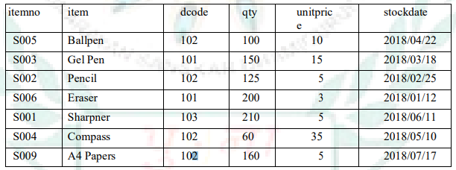

a) Display all the items in the ascending order of stockdate.
SELECT*FROM STOCK ORDER BY STOCKDATE;

b) Display maximum price of items for each dealer individually as per dcode from stock.
SELECT DCODE, MAX(UNIPRICE) FROM STOCK GROUP BY CODE

c) Display all the items in descending orders of item names.
SELECT*FROM STOCK ORDER BY ITEM DESC;

d) Display average price of items for each dealer individually as per dcode from stock which average price is more than 5.
SELECT DCODE,AVG(UNITPRICE) FROM STOCK GROUP BY DCODE HAVING AVG(UNITPRICDE)>5;

e) Display the sum of quantity for each dcode.
SELECT DCODE,SUM(QTY),FROM STOCK GROUP BY DCODE;

SET -3

Write SQL statements for the following queries (i) to (v) based on the relations
CUSTOMER and TRANSACTION given below:

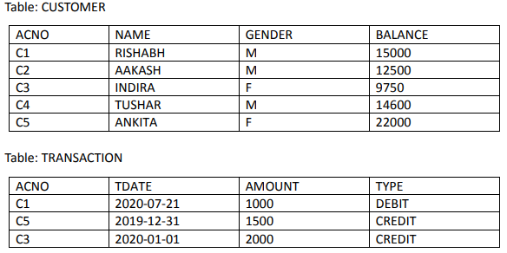
1. To display all information about the CUSTOMERS whose NAME starts with 'A'.
SELECT NAME FROM CUSTOMER WHERE NAME LIKE “A%”;

2. To display the NAME and BALANCE of Female CUSTOMERS (with GENDER as 'F') whose
TRANSACTION Date (TDATE) is in the year 2019.
SELECT NAME , BALANCE FROM CUSTOMER C ,TRANSACTION T WHERE GENDER=’F’ AND C.ACNO=T.ACNO AND YEAR(TDATE)=2019;

3. To display the total number of CUSTOMERS for each GENDER.
SELECT GENDER,COUNT(NAME) FROM CUSTOMER GROUP BY (GENDER);

4. To display the CUSTOMER NAME and BALANCE in ascending order of GENDER.
SELECT NAME,BALANCE FROM CUSTOMER ORDER BY GENDER ASC;

5. To display CUSTOMER NAME and their respective INTEREST for all CUSTOMERS where
INTEREST is calculated as 8% of BALANCE.)
SELECT NAME,(BALANCE*8/100) AS ‘INTEREST’ FROM CUSTOMER;

SET -4

Write the output of the queries (i) to (iv) based on the table
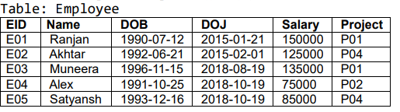
i SELECT NAME, PROJECT FROM EMPLOYEE ORDER BY NAME DESC;
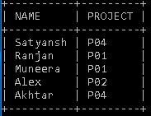
ii SELECT NAME, SALARY FROM EMPLOYEE WHERE NAME LIKE 'A%';
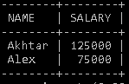
iii SELECT NAME, DOJ FROM EMPLOYEE WHERE SALARY BETWEEN 100000 AND 200000;
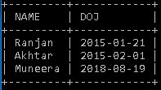
iv SELECT * FROM EMPLOYEE WHERE PROJECT = 'P01';
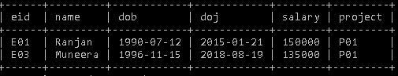
SET -5

Consider the tables PRODUCT and BRAND given below:
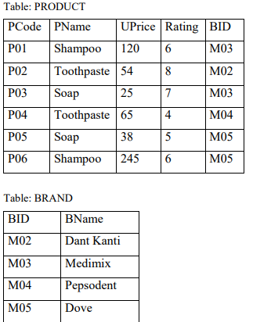
Write SQL queries for the following:
(i) Display product name and brand name from the tables PRODUCT and BRAND.
SELECT PNAME,BMANE FROMN PRODUCTS P,BRAND B WHERE P.BID=B.BID;

(ii) Display the structure of the table PRODUCT.
DESC PRODUCTS;

(iii) Display the average rating of Medimix and Dove brands
SELECT BNAME,AVG(RATING) FROM PRODUCTS P,BRAND B WHERE P.BID = B.BID GROUP BY BNAME HAVING BNAME = ‘MEDIMIX’ OR BNAME = ‘DOVE’;

(iv) Display the name, price, and rating of products in descending order of rating.
SELECT PNAME,UPRICE , RATING FROM PRODUCTS ORDER BY RATING DESC;

SET -6

Charu has to create a database named MYEARTH in MYSQL.
She now needs to create a table named CITY in the database to store the records of various cities across the globe. The table CITY has the following structure:
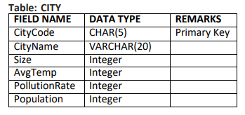

SOLUTION:
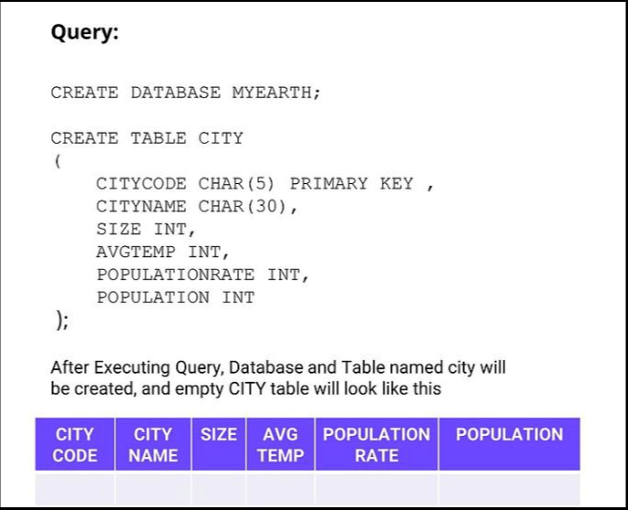
SET -7

Consider the following DEPT and EMPLOYEE tables.

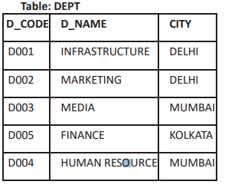
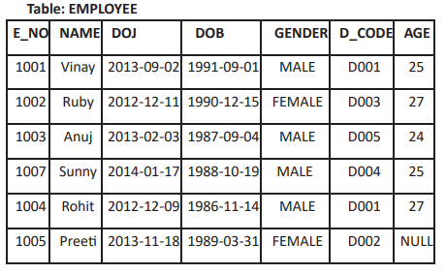

Note: DOJ refers to date of joining and DOB refers to date of Birth of employees.
Write SQL queries for the following:
SET -7 [SOLUTION]
- To display D_NAME and CITY from table DEPT where D_NAME ends with letter ‘G’ and CITY is ‘DELHI’.
SELECT D_NAME,CITY FROM DEPT WHERE D_NAME LIKE “%G” AND CITY=”DELHI”;

- To delete data of all those employees whose age is less than 25.
DELETE FROM EMPLOYEE WHERE AGE<25;

- To update AGE to 23 of those employee whose E_NO is 1004.
UPDATE EMPLOYEE SET AGE=23 WHERE E_NO=1004;

d. To change the sequence of DOB column in employee table and move it before DOJ column.
ALTER TABLE EMPLOYEE ADD COLUMN MOBILE INT(20);

